Different Banner Volume Curve

According Data in Mysql, I have just get some banner example to make the curve of volume(going different along with time).

Data samples summary is as bellow:

There are 618 days, with 128 banners. With different banner with different records, the most is MT-Others-East with 211517 records, the least is LPPZ with 16 records(So some of banners are not with every day purchase from distributor).

I have made 2 time periods for now, One is just by day, the other is by week, the volume changes with different period is as bellow pictures:

For banner_name is ‘**Family mart**’:

As for By Week volume is bellow:

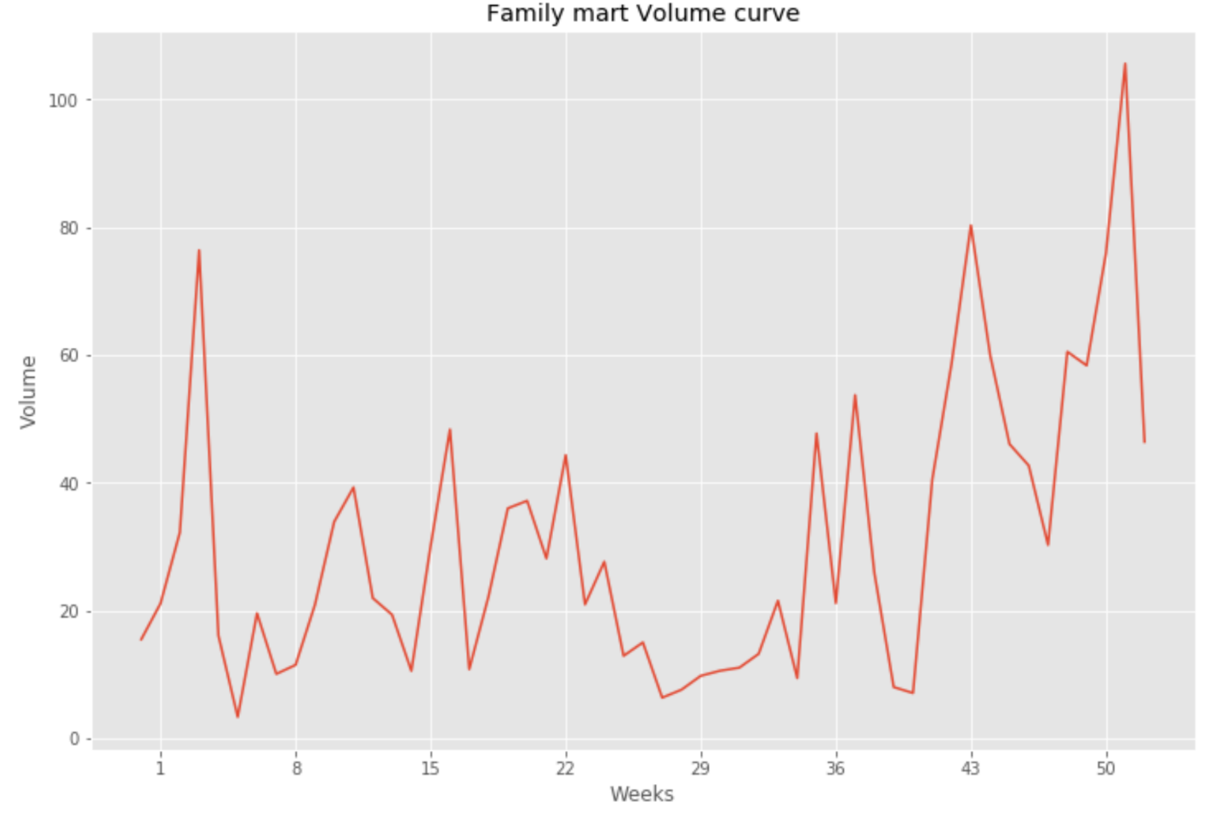

Noted: x tick is week, number 8 mean 8th weak, y tick is **sum** of this week Volume.

By Day:

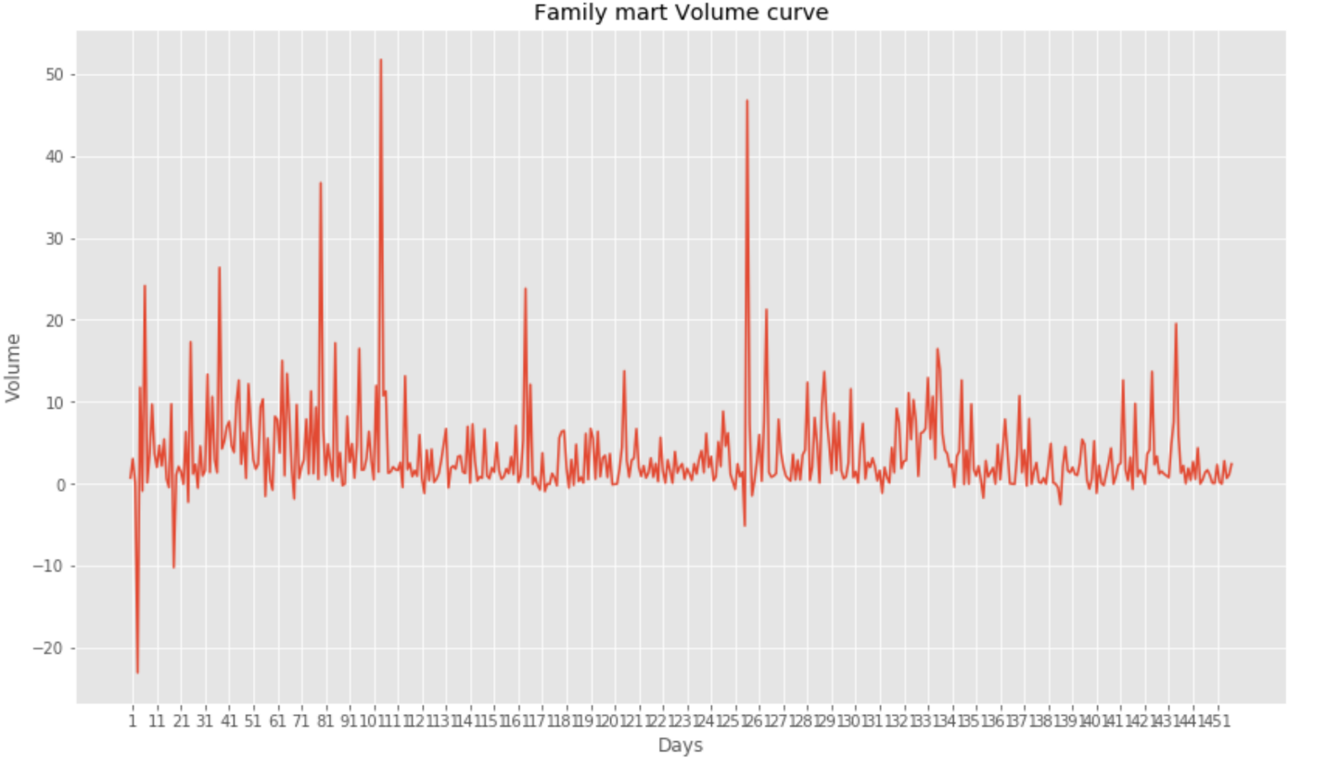

Noted: x tick is day every 10 days showed, y tick is Volume of **every** day volume.

As For banner_name is ‘**Walmart’**:

By week:

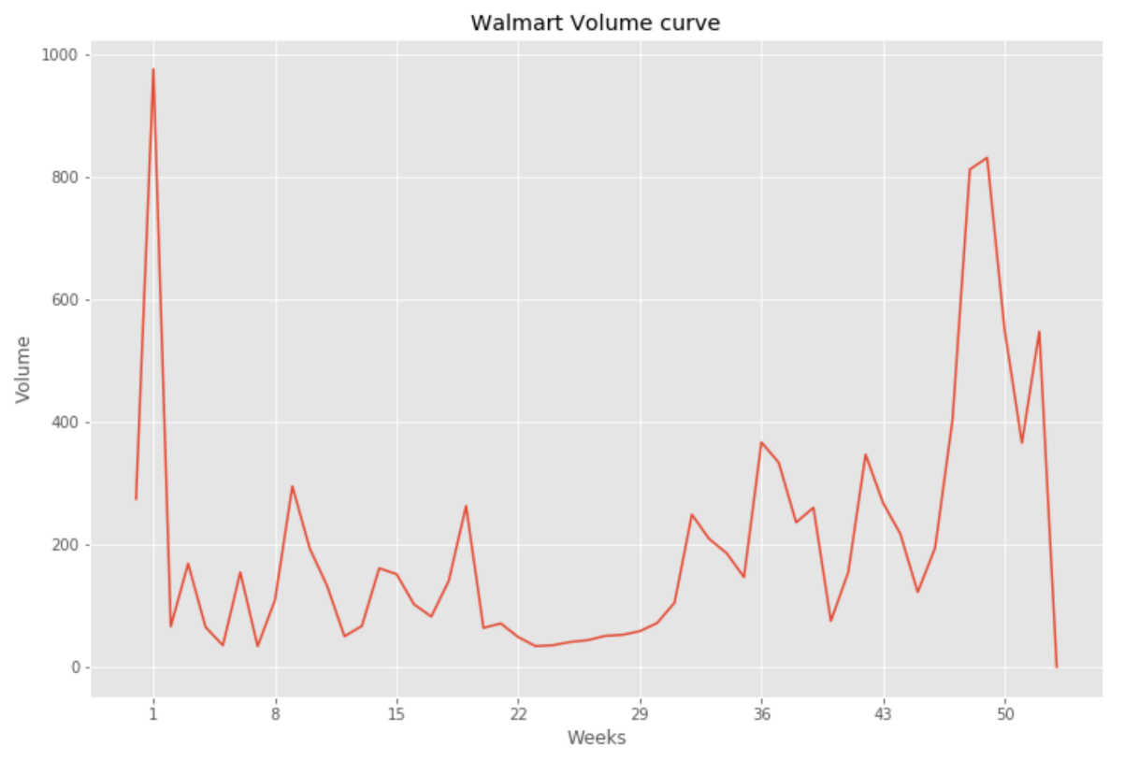

By day:

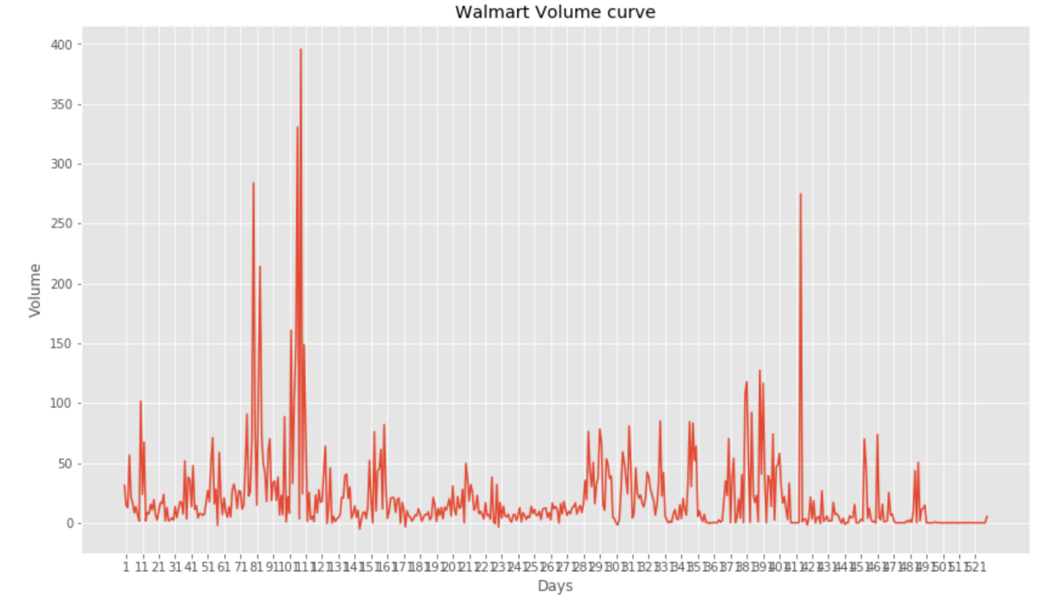

Summary:

For different banners, their volumes change much with each other, because their own features influence their volumes. Also we can see by week and by day with different trend, Because of our data is about 2 years data, if we combine data by week, so we may get about 60 samples for each banner, if by day, we can get more data for model training.